Macroplast UR 7225 B
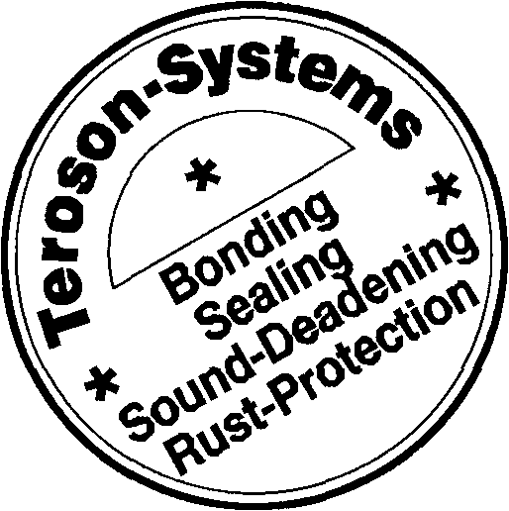
Technical Data Sheet Status: 97-06-09
One Component Adhesive Solvent Free, Moisture Curing, Accelerated Basis: Polyurethane

Macroplast UR 7225 B is a solvent-free, moisture curing one component adhesive based on polyurethane in an accelerated formulation. At room temperature and the required humidity in the joint sufficient strength will be obtained after approximately 25-35 minutes.
Characteristics
Application Area
For faster curing Macroplast UR 7225 B can be cured in a heated press. Maximum temperature must not exceed 70°C.
Macroplast UR 7225 Bis used for the manufacture of sandwich elements of porous substrates (e.g. wood) which contain humidity. The substrates can be bonded to one another or to metals, laminated panels, various plastics, rigid foam made of polystyrene, polyurethane, PVC, and others.

Technical Data
Colour:
Odour:
Consistency:
Density:
Polyurethane content:
Viscosity:
Equipment:
Temperature:
Open time at 20°C:
Curing times
Initial strength:
Final strength:
Shear strength (tested at
wood/wood specimen)
at -40° C:
at 20°C:
at 80°C:
In service temperature range:
Short exposure (up to 1 h):
dark brown
weak characteristic smell
liquid
ca. 1,15 g/cm³
100%
8,000±2,500mPa.s
Brookfield RVT
20°C
12-15 mins*
after 25-35 mins * after 1 d at ambient temperature *
>7MPa >6MPa >3MPa -40°C to 80°C 100°C

* measured after adding a dosed amount of water by spray application
Application
Preliminary remark
Prior to application it is necessary to read the Safety Data Sheet for information about precautionary measures and safety recommendations. Also, for chemical products exempt from compulsory labelling, the relevant precautions should always be observed.
Macroplast UR 7225 B / Edition 1 Status: 97-06-09 1 of 2

Pretreatment of the surfaces to be bonded
The substrates should be free of oil, grease and coarse dirt. Metals are to be wash-coated with a suitable primer, especially, if subsequent exposure of the adhesive to moisture is expected.
Application
Macroplast UR 7225 B is applied to one substrate by spatula or doctor blade, but can also be applied by spraying.
When bonding substrates without sufficient humidity or which are not moisture permeable, the required amount of moisture has to be provided by other methods. A proven procedure is the combined spraying of the adhesive simultaneously with water in a fine mist. In the case of separate adhesive and water mist application the water must not be sprayed onto the bare metal but to the other substrate or - even better - to the adhesive.
Bonding surfaces should be brought together immediately after adhesive application, assuring sufficient contact pressure during curing, preferably in a press.
Since Macroplast UR 7225 B cures by reaction with humidity open containers must always be properly sealed tight against moisture immediately after taking out the needed amount. For the same reason we recommend touse up opened containers as soon as possible.
Cleaning
Fresh, uncured material (cleaning application equipment, substrate contamination etc.) can be removed with cleaner Macroplast B 8030; cured adhesive can only be removed mechanically.

Storage
Packaging
Frost-sensitive
Recommended storage temp. Shelf-life
Drum Container
Hazard Indications/ Safety Recommendations/ Transport Regulations
yes
15°C to 25°C (not < 10°C and > 50°C)
9 months in original packaging
200kg ca. 1000 kg
see Safety Data Sheet

The above data, particularly the recommendations for application and use of our products are based on our knowledge and experience. Due to different materials and conditions of application which are beyond our knowledge and control we recommend strongly to carry out sufficient tests in order to ensure that our products are suitable for the intended processes and applications. Except for wilful acts any liability based on such recommendations or any oral advice is hereby expressly excluded.
Important
This Technical Data Sheet supersedes all previous editions.

REG NO 3S 084

Teroson
A Henkel Group Company
Germany:
Henkel Teroson GmbH D-69112 Heidelberg
Telefon (06221) 704-0 Telefax (06221) 704-698 Telex 461 428-10
UK:
Teroson UK
Cromwell Road
St. Neots
Cambridgeshire
PE 19 2JW
Telephone (01480)404505
Telefax (01480)406111

Macroplast UR 7225 B / Edition 1 Status: 97-06-09 Page 2 of 2

